PartⅠOverview-1 Introduction
Assignment 20%
Project 50%
Final exam 30%

PartⅠOverview-2 Software Quality and Bugs
- Software quality factors:
- Product revision--Maintainability
- Product transition--Portability, Interoperability
- Product operations--Functionality, reliability, efficiency, usability
- Product operations
- Functionality: give the user what they want in a correct way, and nothing more.
- Suitability: provide an appropriate set of functions for specified tasks and user objectives.
- Correctness: provide the right and agreed.
- Compliance: adhere to application.
- Security: prevent unintended access and resist deliberate attacks.
- Usability:minimize the effort for use of the software.
- Understandability: enable the user to understand whether the software is suitable, and how it can be used for particular tasks and conditions of use.
- Learnability: enable the user to learn its application.
- Operability: enable the user to operate and control the software.
- Likability: to be liked by the user.
- Reliability:the probability of failure free operation of a computer in a specified environment for a specified time.
- Availability: in a state to perform a required function at a given point in time.
- Fault tolerance: maintain a specified level of performance in cases of software faults or infringement of its specified interface.
- Recoverablity: re-establish the level of performance and recover the data directly affected in the case of a failure.
- Robustness: the degree to which a system or component can function correctly in the presence of invalid inputs or stressful environmental conditions.（健壮性）
- Maintainability:the ease of maintaining the software(the capability of the software to be modified).
- Changeability:enable a specified modification to be implemented.
- Stability:minimize unexpected effects from modifications of the software.
- Testability:enable modified ssoftware to be validated.
- Portability:the capability of software to be transfered from one environment to another.
- Interoperablity:the capability of a system to work with other systems.
- A brief history of software engineering:
- The functional era(1960 and earlier): how to make the program.
- The schedule era(1970s): how to make the program before deadline.
- The cost era(1980s): how to make the program before the deadline at the budgeted cost.
- The quality era(1990s and today: how to make the program before the deadline at the budgeted cost and with good quality.
- The iron triangle rule of software development:
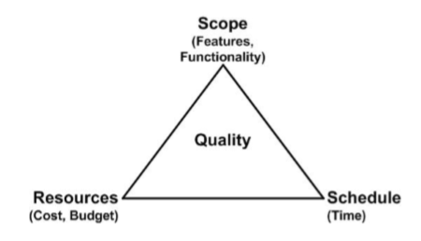
- Concepts: failure, fault and error
- Failure: observable incorrect behavior or state of a given system.
- Fault: a defect in a system whose presence causes the failure.
- Error: the human mistake that produce a fault.
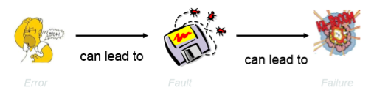

PartⅠOverview-3 Software Quality Control
- Bugs are much more than coding mistakes(50%以上来源于需求描述)
- The earlier a bug is found, the cheaper it costs.
- Difficulty of writing bug-free programs:
- Complexity
- Many parameters.
- No two parts of software are alike.
- System goes through many states during execution.
- Inherent non-linearity.
- Conformity-system should conform with standards imposed by
- Other components, such as hardware
- External bodies, such as existing software
- Changeability-constant need for change
- Quality control&Quality assurance
- Quality assurance: a set of activities designed to ensure that the development and/or maintenance process is adequate to ensure a system will meet its objectives.
- Quality control: a set of activities designed to evaluate a developed work product.
- Differences:
- QA focus on the process elements of a project.
QC activities focus on finding defects in specified deliverable.
- QA makes sure you are doing the right things, the right way.
QC makes sure the results of what you’ve down are what you expected.
- QA is process oriented.
QC is product oriented.
- QA is independent of the project team--observe, but not participate the development process.
QC is part of the project team--examine whether the product satisfies the quality requirement.
- Verification and validation
- Validation: does the software system meets the users’ real needs? Are we building the right software?
- Verification: does the software system meets the requirements specifications? Are we building the software right?
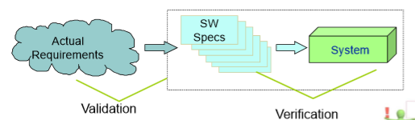
- Software verification techniques
- Inspection: code review
- Model checking: the program to be absolutely correct with respect to some formal properties on any input.
- Program analysis: identifying certain problematic code patterns that are known to be bug-prone.
- Testing: finding bugs by executing input cases and comparing the outputs with some references system.
- Sound vs. Complete
- Sound: an analysis of a program P with respect to a property p is sound if the analysis returns true only when the program does satisfy this property.
- Complete: an analysis of a program P with respect to a property p is complete if the analysis always returns true when the program actually does satisfy the property.
- Static vs. Dynamic
- Static: an analysis is static if it can infer the properties without running the program.
- Dynamic: an analysis is dynamic if it can infer the properties by running the program.
- Inspection(code reviews):
- Who: original developer and reviewer, sometimes together in person, sometimes offline.
- What: reviewer gives suggestions for improvement on a logical and/or structural level, to conform to previously agreed upon set of quality standards.
- When: when code author has finished a coherent system change that is otherwise ready for checking.
- The merit of inspection:
- Two heads are better than one.
- Force the programmer to keep it simple and stupid.
- Any piece of code is understood by at least two personals.
- Model checking:
- Calculate whether a system satisfies a certain behavioral property:
- Is the system deadlock free?
- Whenever a packet is sent will it eventually be received?
- ......
- Different from testing: look at all possible behaviors of a system.
- Static, complete but not sound.
- Proof of no bug.
- But expensive.
- Program analysis:
- Target certain know bug-prone code patterns:
- Type analysis
- Dead code analysis
- Escape analysis
- Clone analysis
- Pointer analysis
- Static, complete and some are sound.
- Pros:
- Quick
- Cheap to apply
- Cons:
- False positive
- Might mask the real causes
- Testing
- IEEE definition: the process of exercising or evaluating a system or system components by manual or automated means to verify that it satisfies specific requirements and to identify difference between expected and actual results.

PartⅠOverview-4 Roadmap of Testing
- Concepts in testing:
- Testing: the process of executing a program with the intent of finding errors.
- Debugging: finding and fixing faults in the code.
- Test input: data or operation sequence to drive the execution of the subject under test.
- Test oracle: a mechanism for determining whether a test run has passed or failed.
- Test case: test input+test oracle.
- Test harness(测试框架): a collection of software and test data configured to test a program by running it under varying conditions and monitoring its behaviors and outputs.
- PMOD:
- Problems：
- Fundamental problems: test adequacy, test oracle, test generation.
- Other important problems: test automation, test management.
- Methods:
Exploratory testing, black box testing, white box testing, model-based testing.
- Objectives:
- Functional testing
- Performance testing
- Regression testing
- Security testing
- Compatibility testing
- Domains：
Database, mobile, game, multi-threaded, web application...
- Problem(PMOD)
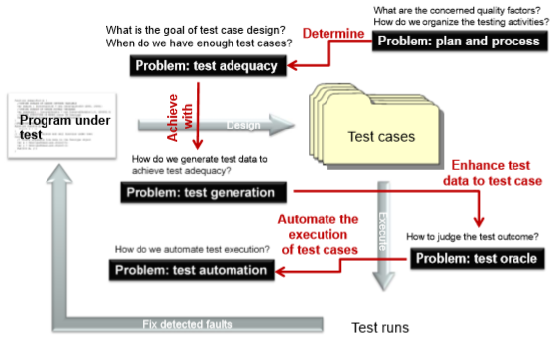
- Methods(PMOD)
- Exploratory method: explore the software while designing and executing tests simultaneously.
- Black box method: treat the program as a black box, ignoring its internal structure.
- White box method: logical analysis of code element.
- Model-based method: based on a formal model of the software.
- Objectives(PMOD)
